Final Project: Detroit City Planning
by Skylar Bohan
Part One: Raster Analysis
Objective: Detroit is seeking to build a new school to support their growing population of K-5 school aged children and balance out overcrowded schools. The new school site selection will be based off multiple factors: population density of school aged children, proximity to existing schools, and level of crime in the area.
Data Downloaded:
- Detroit Educational Institutions, Shape File from City of Detroit Open Data Portal. Point data representing existing schools to use for existing school proximity raster.
https://data.detroitmi.gov/datasets/c7e8bcbeedac41c6b0565d79975644ab_0/explore?location=42.329967%2C-82.934571%2C9.84
- City of Detroit Boundary, Shape File from City of Detroit Open Data Portal. Vector layer boundary for City of Detroit for mask for raster analysis and cartographic purposes. hhttps://data.detroitmi.gov/datasets/86b221bb68ca4364afe81d156e54f95c_0/about
- ACS Population Variables – Boundaries, Shape File from Esri Demographics Team. Vector layer of 2022 American Community Survey population estimates by age groups to figure out where school aged children live.
https://hub.arcgis.com/datasets/esri::acs-population-variables-boundaries/explore?layer=2&location=42.402678%2C-83.002411%2C11.12
- RMS Crime Incidents, Shapefile from City of Detroit Open Data Portal. Vector layer with points representing crime incidents from 1915 until the current year. Will use filtered results for raster analysis representing higher crime areas. https://data.detroitmi.gov/datasets/871c66cb1faf458b9d80b5dba1fc08c8_0/explore?location=42.315016%2C-83.074325%2C11.89&showTable=true
Rater Analysis Steps:
- Prepare data for raster analysis:
  - “RMS Crime Incidents” point layer contains historical crime data, and incidents which don’t impact student safety or school property. Selected by attribute for incidents no older than 2022 and removed most non-violent crimes except those which may impact school or student property negatively. Saved selected features as new layer “RMS Crime Incidents 2022-2024”.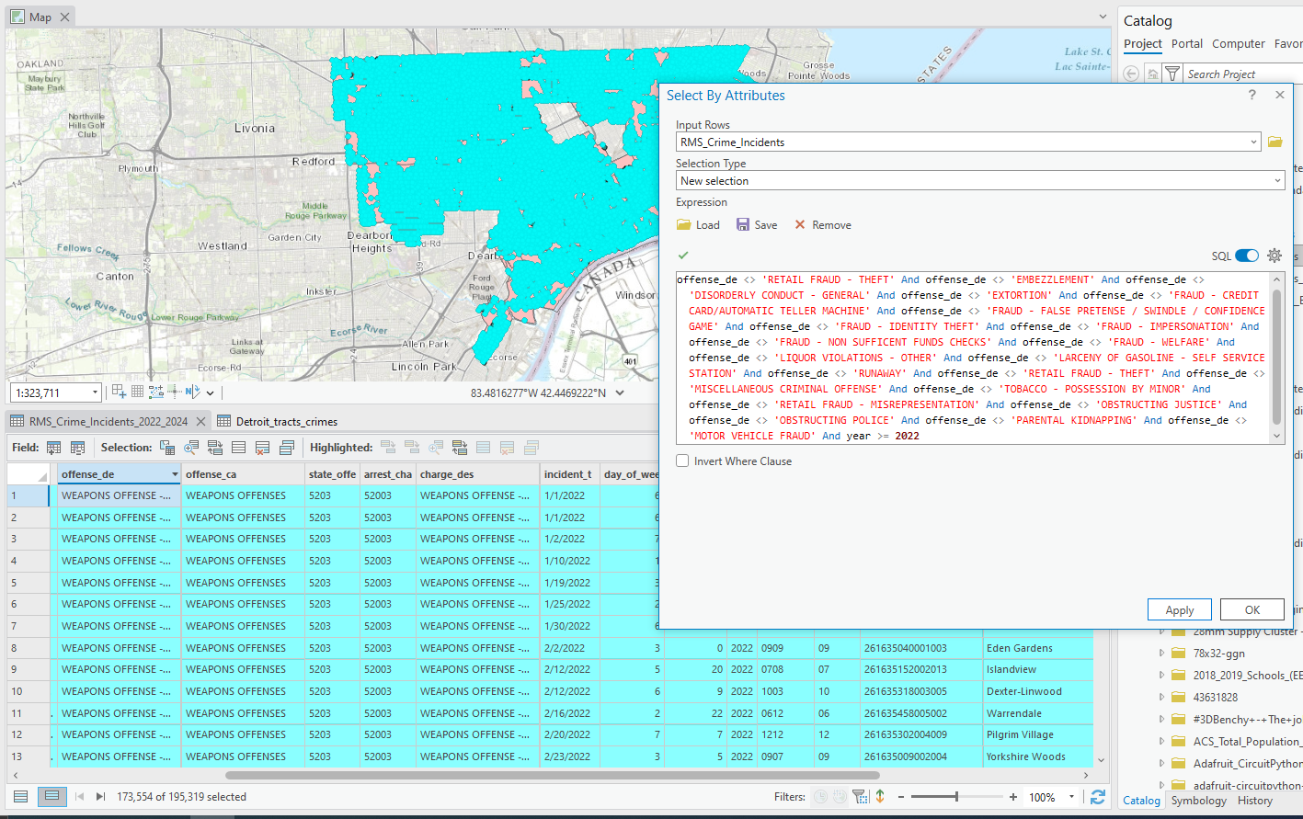
  - ACS Tract layer contains tracts outside of Detroit city boundaries. Used Clip Tool with “Tract” layer as input feature and “City of Detroit boundary” layer as clip feature 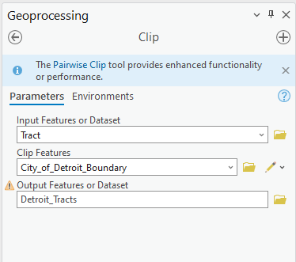
  - Using Summarize Within tool to create field in “Detroit Tracts” summarizing number of Crime Incidents within each tract 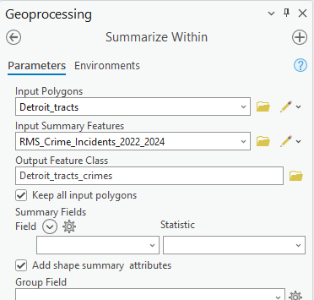
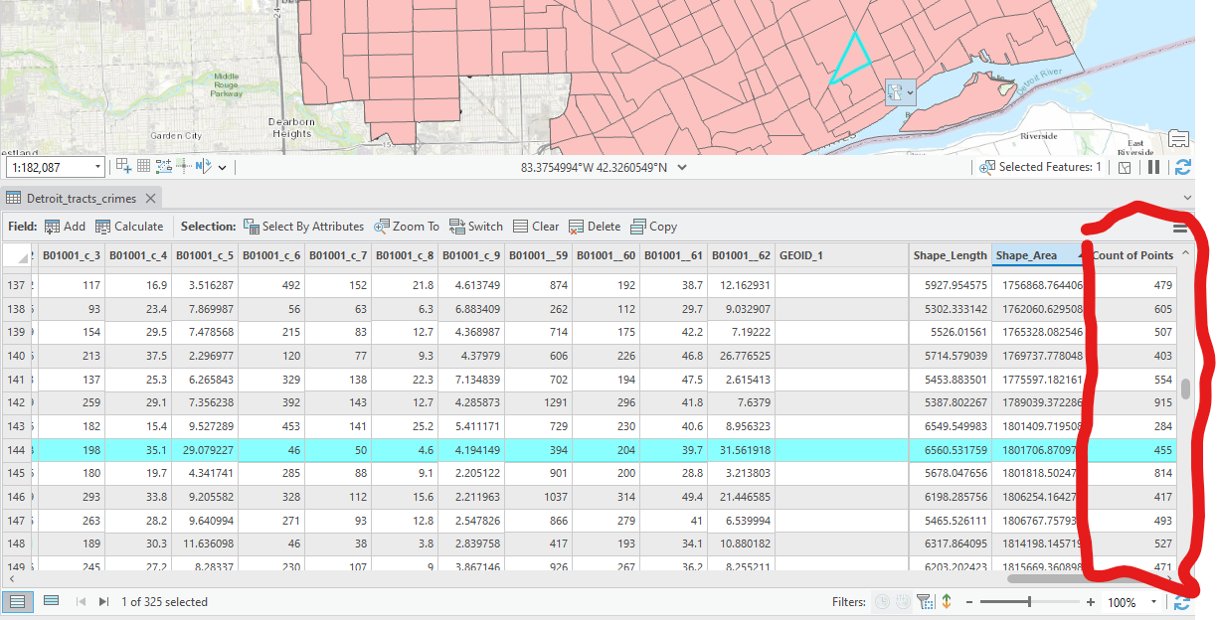
  - “Detroit Tracts” has populations separated by male and female, created new field called Pop_5to9, and used calculated field tool to generate data summing the male and female age 5-9 population fields.
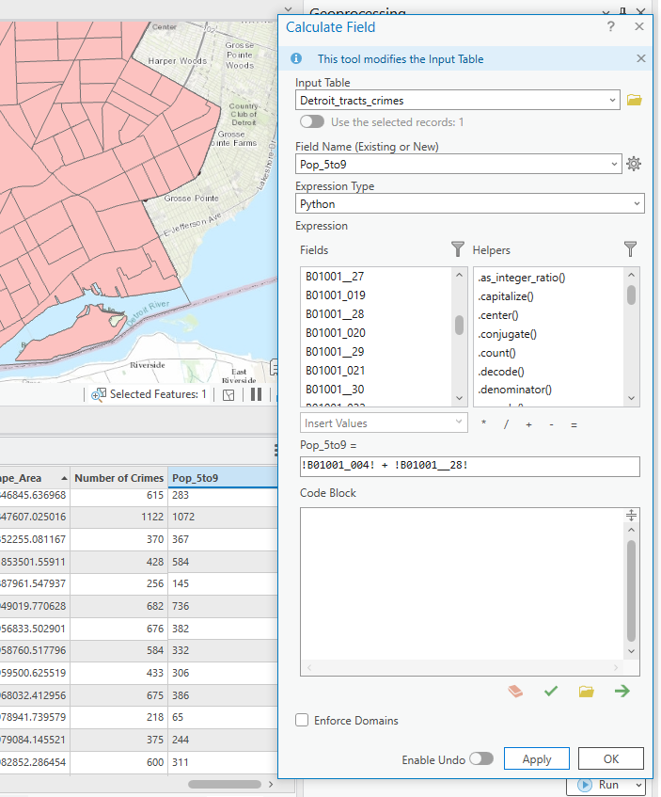
  - “Detroit Educational Institutes” contains more than just k-5 educational facilities and closed schools, used select by attribute to select only sites that are schools to serving k-5 students using authorized grades field and that are currently open. 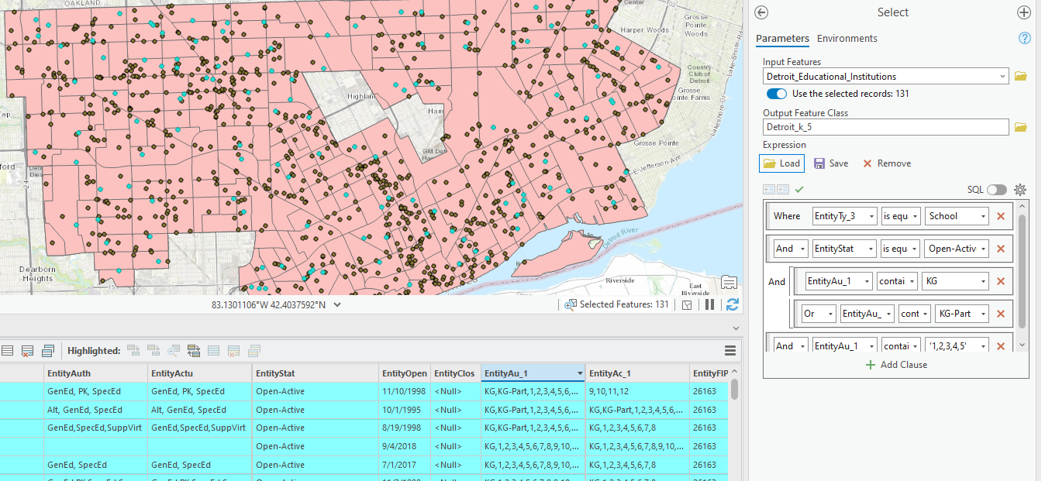
- Create Raster Layers to use for Raster Calculator
  - Use feature to raster tool with Detroit Tracts polygons, generate one raster each using fields “Number of crimes” and “Pop_5to9”. 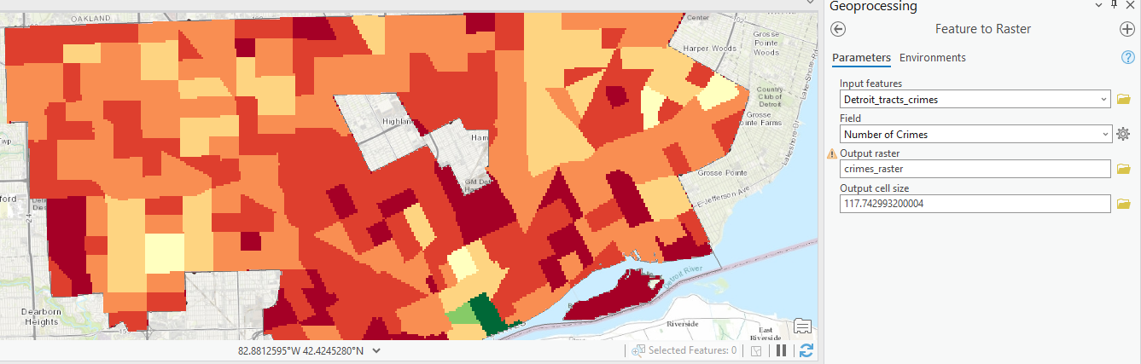 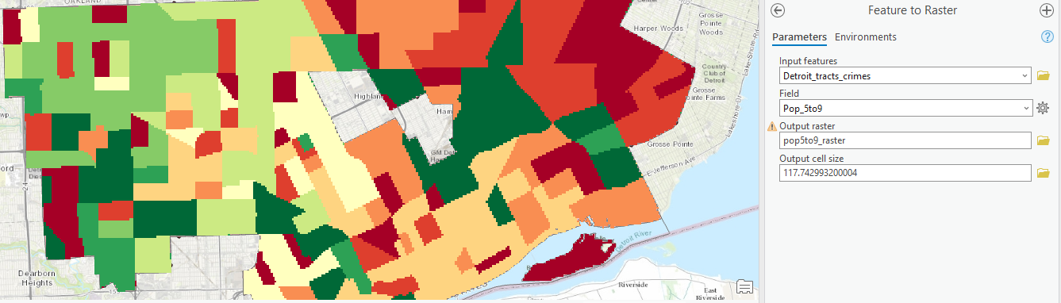
  - Create euclidean distance raster using “T2018_2019_Schools” layer, and utilizing city boundaries layer as mask.
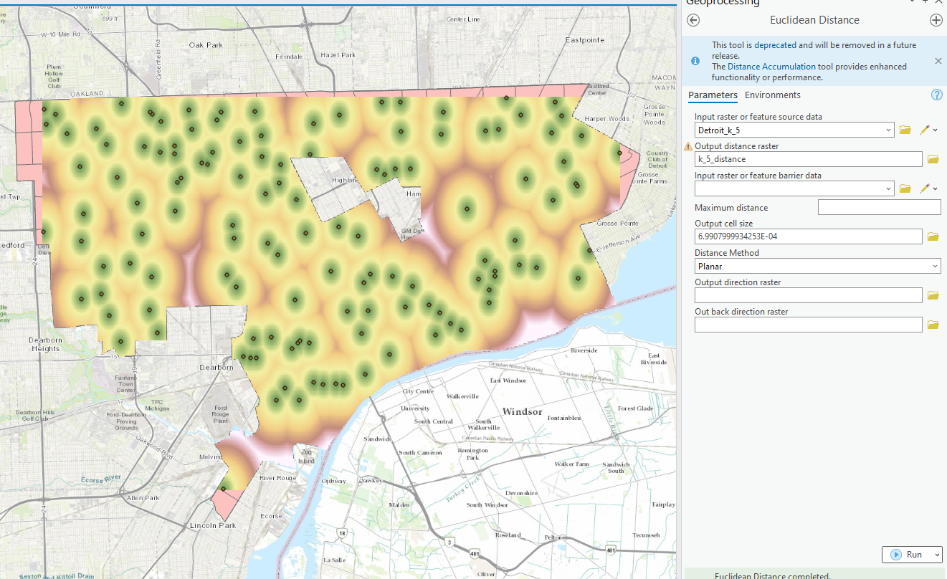
  - Reclassify the three raster layers: “crime_raster”, “pop5to9_raster”, and “k_5_distance in to 10 classes. 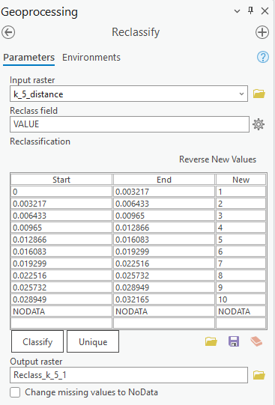
  - Use Raster Calculator to generate raster representing site suitability for new school. Weighted with 50% population kids 5-9, 30% distance to other k-5 schools, and 20% crime incidents within last two years. 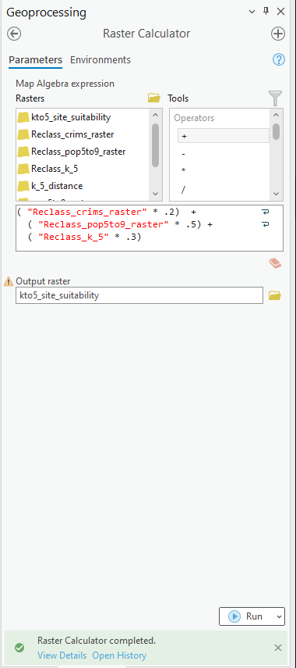
- Final Map
